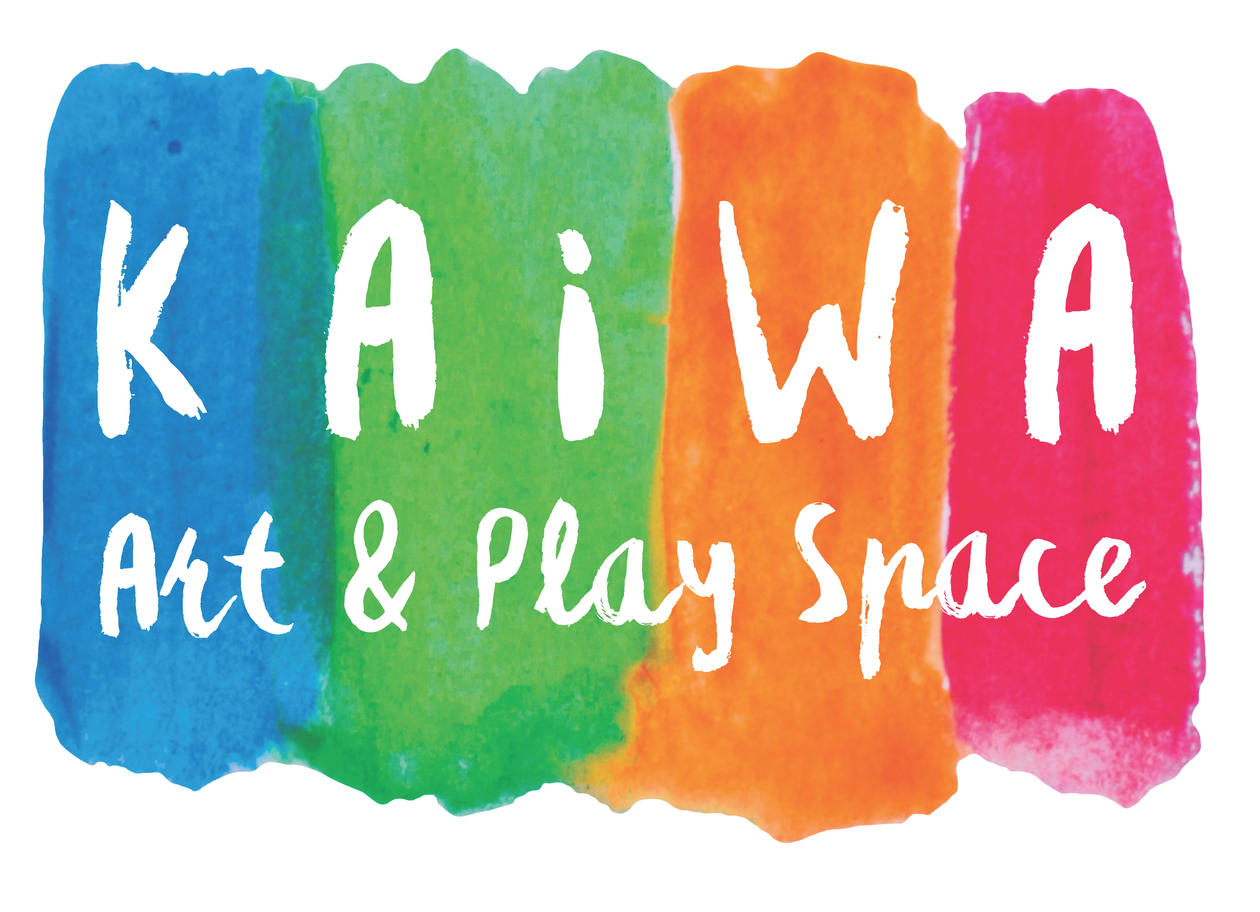
Kaiwa Art and Play Space Evaluation Form
Thank you for your support of Kaiwa’s programming! Kaiwa wants to learn how to best serve the Santa Cruz community - especially the families who have helped make Kaiwa such a magical and inspiring place during its first few months. Please take a few minutes to reflect on you and your child’s experiences to help Kaiwa grow. Honesty is appreciated. Kaiwa is looking forward to providing more challenging and rewarding art experiences for your children!

Student’s Name:________________________________________ Age:__________

Program Name:_________________________________________

Guardian/Parent:______________________________________________________

How do you feel about your child’s overall experience at Kaiwa?

What was the most positive part of Kaiwa’s programming?

In what ways do you think Kaiwa could improve its programming and/or management?

Please tell us more information on programs and offerings you would like to see in the future at Kaiwa Art and Play Space!

